Factors that Influence Surface Plasmon Resonance in Dielectric Films

Dan Marshall, Andrew Hoeft, Michael O’Connor, Dr. Todd Zimmerman

University of Wisconsin – Stout

Acknowledgements

The team of researchers would like to thank Dr. Todd Zimmerman, Dr. Matthew Ray, and Emily Kopp for assistance throughout the research project. Special thanks to the University of Wisconsin – Stout Department of Chemistry and Physics for funding.

Contents

Abstract 3

Factors that Influence Surface Plasmon Resonance in Dielectric Films 4

1) Introduction 4

2) Background 4

Total Internal Reflection 4

Evanescent Fields 5

Surface Plasmon Resonance Theory 5

3) Methodology 6

Experimental Setup 6

Configuration and calibration. 6

Procedure 9

Preparation of specimen and analysis of film thickness. 9

Data collection. 15

4) Results 16

Topological scanning using AFM 16

Experimental data 20

5) Discussion 25

SPR Determinations 25

Future Research 25

References 26

Abstract

Surface plasmon resonance is a phenomenon that takes advantage of evanescent wave and surface plasmon wave coupling to utilize in biosensing technologies. An apparatus consisting of a light source, prism, dielectric film, and a photodetector can be used to measure the effects SPR. The goal of the experimentation was to determine the factors that influence SPR in dielectric films. The main factors of SPR explored being film material, film thickness, incident angle, iris diameter, interface roughness, and material contaminations.

Factors that Influence Surface Plasmon Resonance in Dielectric Films

# 1) Introduction

Surface plasmon resonance (SPR) has been utilized for biosensing technology since the 1990’s. It is a common technique that takes advantage of wave properties for material detection and identification. “Surface plasmon resonance (SPR)-based optical biosensors are now being used extensively to define the kinetics of wide variety of macromolecular interactions and high- and low-affinity small molecule interactions. (Pattnaik, 2005)” With such a versatile tool the parameters of SPR came into question. What are the factors that influence surface plasmon resonance in dielectric films?

The hypothesis was that the film material, film thickness, and the angle of incident light are the main contributing factors to achieving SPR.

# 2) Background

## Total Internal Reflection

Light always travels the path of that takes the least amount of time. Depending on the material that light is traversing through the angle of light will change to achieve least resistance. When passing through a material with a higher index of refraction to a lower one the light is bent towards the plane of the surface. Once the incident angle widens enough the light achieves a critical angle. Any angle past the critical angle will be reflected also known as total internal reflection shown in figure 2.1.

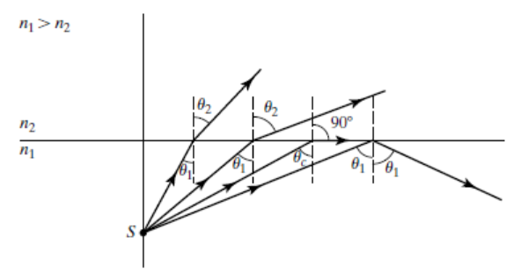

Figure 2.1 Critical angle and total internal reflection diagram (Pedrotti, Pedrotti, & Pedrotti, 2017)

The critical angle can be measured using Snell’s Law. Equation 2.1 is a modified version of Snell’s Law to solve for the angle at which total internal reflection starts to occur.

**Equation 2.1**

$$θ_{critical}=\sin^{-1}{\frac{n_{t}}{n_{i}}}$$

$n_{t}$ is index of refraction for the gold medium, $n_{i}$ is the index of refraction for the glass prism, and $θ_{critical}$ is the critical incident angle

With the critical angle known, all angles greater than its value is where SPR can occur.

## Evanescent Fields

An evanescent field is the range that an exponentially decaying evanescent wave propagates. Evanescent waves occur when electromagnetic waves are reflected off a surface at an angle greater than the critical angle. An angle greater than the critical angle is known as total internal reflection. With total internal reflection no light is passing through the interface, but the electrical field of the electromagnetic wave does extend past the interface. This extending electric field is where the evanescent wave exists. Since the evanescent wave is a sinusoidal wave it has a wave number represented by the evanescent wave equation shown in equation 2.2.

**Equation 2.2**

$$k_{evan,||}=\frac{2π}{λ}n_{1}sin⁡(θ)$$

$k_{evan,||}$ is the wave number for the evanescent wave, $λ$ is the wavelength of the incident light, $n_{1}$ is the index of refraction for the glass prism, and $θ$ is the angle of incident light

## Surface Plasmon Resonance Theory

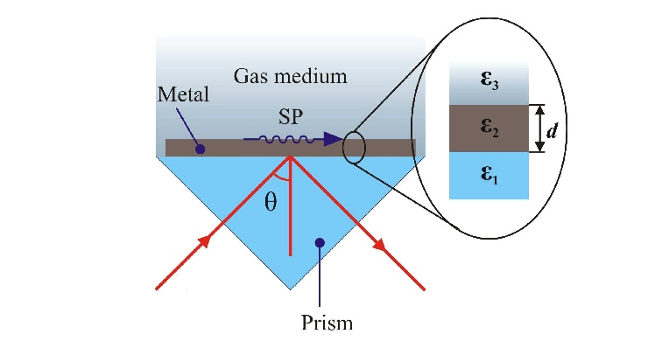

Figure 2.2 Kretschmann configuration for observation of SPR (Cavalcanti & Fontana, 2009)

In figure 1.2 it demonstrates the Kretschmann configuration where the metal medium is in direct contact with desired medium past it. The noble metal used as a dielectric film has conduction band electrons. These electrons absorb the energy of the incident light photons and oscillate converting them into plasmons. The plasmon is the name for the electron density wave which has a wave number represented by equation 2.3 and figure 2.2 existing at the interface between the desired medium and the metal.

**Equation 2.3**

$$k_{sp}=\frac{2π}{λ}\sqrt{\frac{n_{2}^{2}n_{g}^{2}}{n_{2}^{2}+n_{g}^{2}}}$$

$k_{sp}$ is the wave number for the surface plasmons, $λ$ is the wavelength of incident light, $n_{2}$ is the index of refraction for the medium opposite the film and prism, and $n_{g}$ is the index of refraction for the gold medium

The evanescent wave is generated in the interface between the glass prism and the metal film. It penetrates the film and into the medium past. The evanescent wave and the surface plasmon wave interact with one another by coupling. This coupling is represented by the combination of the evanescent wave equation with the surface plasmon wave equation depicted by equation 2.4.

**Equation 2.4**

$$θ_{SPR}=\sin^{-1}\left(\frac{1}{n_{1}}\sqrt{\frac{n_{2}^{2}n_{g}^{2}}{n_{2}^{2}+n_{g}^{2}}}\right)$$

$θ_{SPR}$ is the incident angle where SPR occurs, $n_{1}$ is the index of refraction for the glass prism, $n_{2}$ is the index of refraction for the medium opposite the film and prism, and $n_{g}$ is the index of refraction for the gold medium

When their energies match the plasmons excite to a higher state of energy. After excitation the plasmons deexcite and emit a photon. This photon is released parallel to the incidence light on the opposite side of the interface. Analyzing this emitted light can give insight to the properties of the noble metal used for surface plasmon resonance.

# 3) Methodology

## Experimental Setup

### Configuration and calibration.

For experimental determination of θSPR, a monochromatic (red) LED light (specified wavelength 625nm) with a measured average wavelength of 631nm was positioned at one end of a short tube (item “3” in *Figure 3.1* below) while an iris (ThorLabs 1D12D) was fixed at the other end (item “2” in *Figure 3.1*), affording reasonable control over the diameter of (uncollimated) light emitted. Mounting rods were used to affix a lens / polarimeter combination (ThorLabs AC254-100-A-ML) at a variable distance from the iris while maintaining a fixed polar orientation (item “1” in *Figure 3.1*). In this manner the polarization of emitted light is easily controlled. To ensure accurate calibration of the polarimeter, a handheld polarimeter was used to verify polarization orientation with the graduation scale on the mounted polarimeter.

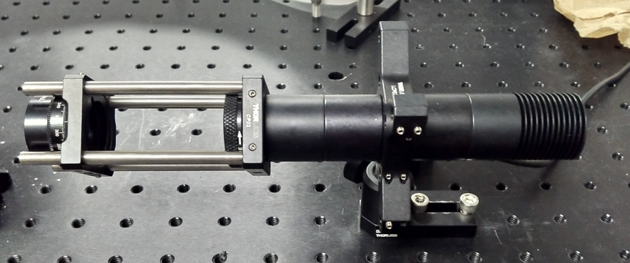

1. Polarimeter

3) LED light

source

2) Iris

Figure 3.1 LED light-source assembly

For specimen location in experimental setup, a stage was manufactured using fused deposition modeling with PLA filament to be affixed to a turntable (denoted by item “2” in *Figure 3.3*) via use of a mounting adapter plate. The stage was designed such that a microscope slide of standard dimension placed against support posts of the stage would position the slide face opposite the support posts to be coincident with the axis of rotation of the turntable. Preliminary alignment of the light source with the axis of rotation was achieved by marking the axis using a caliper and square and positioning the light beam centered on the marked line as shown by arrow in *Figure 3.2* (below).

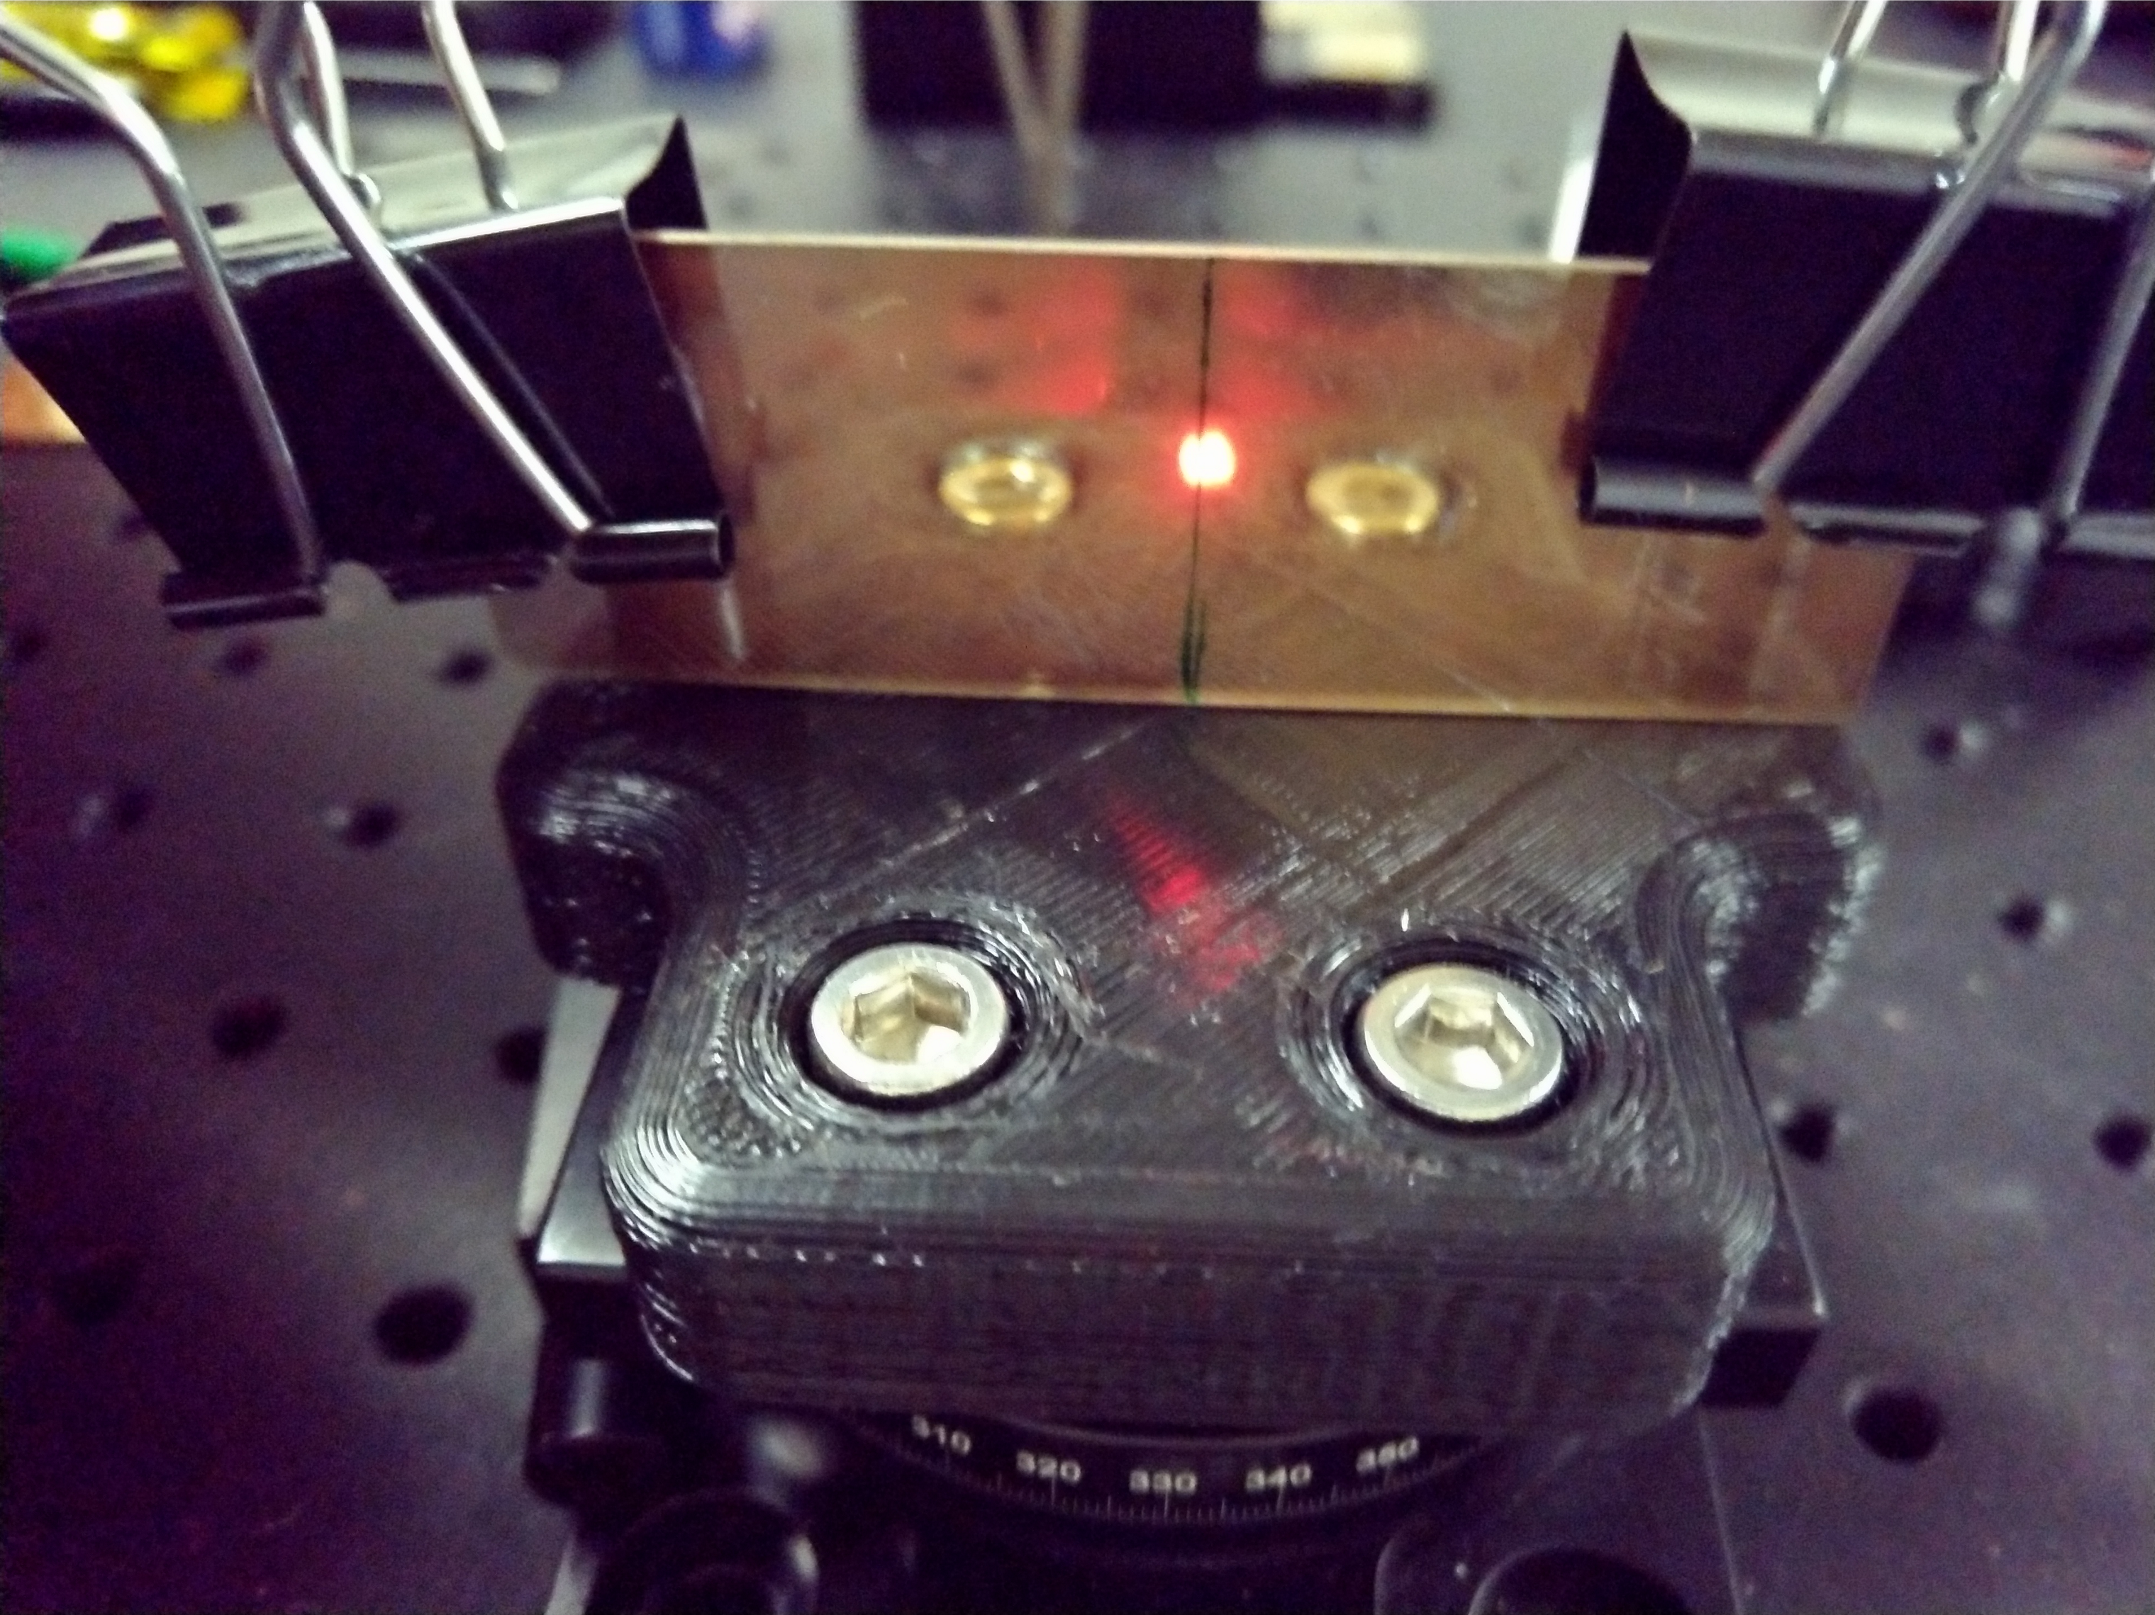

Figure 3.2 Preliminary centering of light source on stage axis of rotation

Standard office paper clips (item “1” in *Figure 3.3* below) were employed for coupling of specimen (slide) and stage (item “4” in *Figure 3.3*). A semi-cylindrical prism of 1 inch diameter (item “3” in *Figure 3.3*) was interfaced with the specimen using index-matching oiland centered on the stage using a caliper. Complete stage and specimen assembly is represented in *Figure 3.3* (below).

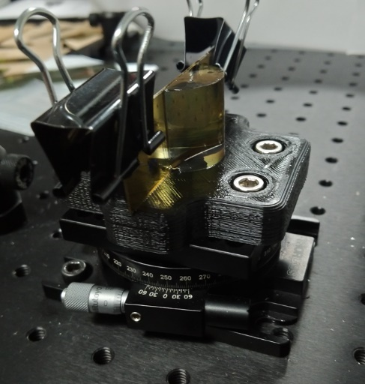

3) Semi-cylindrical

Prism

1. Paper Clip

2) Turntable

4) Stage

Figure 3.3 Stage and specimen assembly with semi-cylindrical prism affixed

Two configurations (which will be referred to henceforth as “configuration A” and “configuration B”) using the same light source and specimen stage setup were employed for experimental analysis. In configuration A, a screen was placed so that each point on the screen was equidistant from the axis of rotation of the specimen stage (screen shown by item “2” in *Figure 3.5* below). Configuration B leverages a ThorLabs S120CS photodiode (item “2” in *Figure 3.4*) with PM100D console (item “1” in *Figure 3.5*) to measure reflected light intensity. A series of rods and ThorLabs RA90 right angle clamps (item “1” in *Figure 3.*4) were used to build a crude framework for mounting of the photodetector sensor. By restricting each joint to a 90-degree angle apart from a single joint which would be rotated about an axis positioned to be collinear to the axis of rotation of the stage (item “3” in *Figure 3.4*), the sensor was mounted in such a fashion that it would remain perpendicular to the reflected light and equidistant from the axis of rotation of the stage, shown in *Figure 3.4 and 3.5* (below).

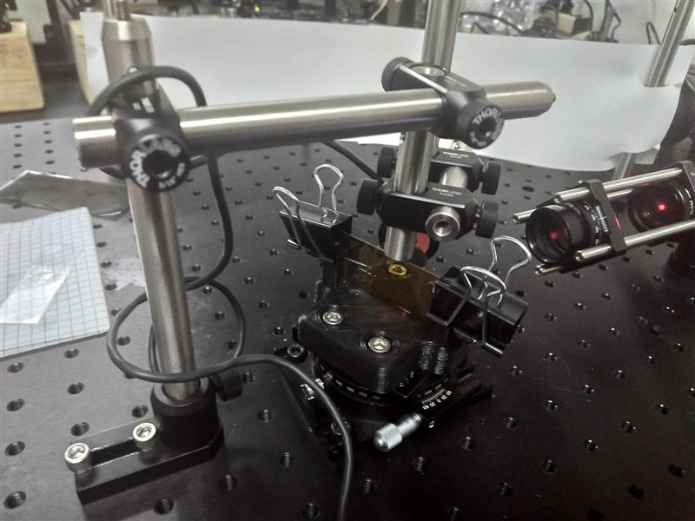

3) Joint rotated for

“Configuration B”

2) Photodiode

1. Right angle clamp

Figure 3.4 Mounting framework for photodetector sensor

2) Paper Screen

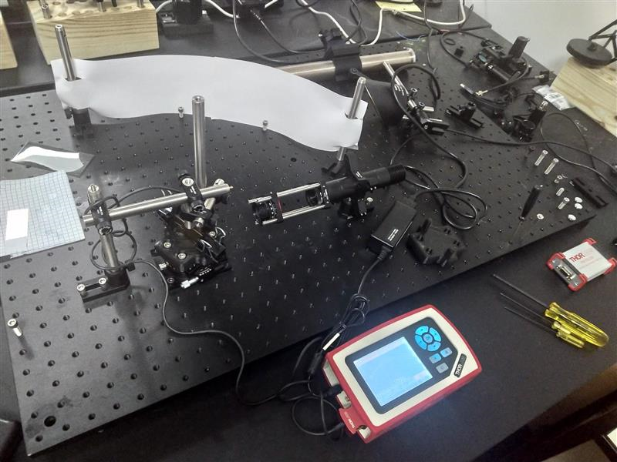

1. Console

Figure 3.5 Configurations A and B both represented

## Procedure

Experimental procedure requires select control over specimen parameters as well as choice of experimental configuration.Specimen parameters such as amount of Au film deposited on microscope slide and side of slide to be coated serve as independent experimental controls, while variation in experimental configuration serves to provide alternative means for detection of SPR phenomenon.

### Preparation of specimen and analysis of film thickness.

1. A microscope slide of standard dimension (76.2mm X 25.4mm X 1mm) is selected for use[**[1]**]. The selected slide is then prepared by washing the surface with isopropyl alcohol and standard lab wipes for removal of possible surface contaminants.

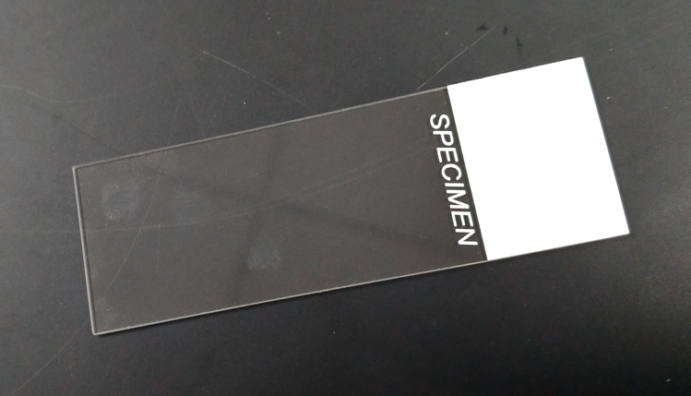

1. Etched labeling surface

(One sided)

Figure 3.7 “Standard” microscope slide with etched labeling surface

1. If a standard (non-optics grade, float glass) microscope slide was selected, orientation of the slide must be considered (see *Figure 3.7* above*)*. Once a determination has been made regarding the orientation of the slide, a section of the end is recommended to be masked with clear tape for the creation of a “step” to be utilized for determining what quantity of Au has been deposited on the slide and is then placed on the substrate holder of the selected sputter-coater in the chosen orientation.
2. ACressington 108-Auto Gold Sputter-Coater is then operated to apply a thin film of Au to the surface of the prepared slide[**[2]**]. For the purpose of this experiment, the only parameter varied concerning sputter-coating process is the duration of operation.

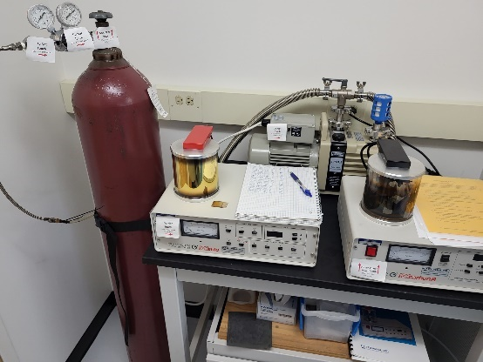

1. Glass cylinder
2. Gas supply valve

Figure 3.8 Cressington 108-Auto Gold Sputter-Coater (Left Unit)

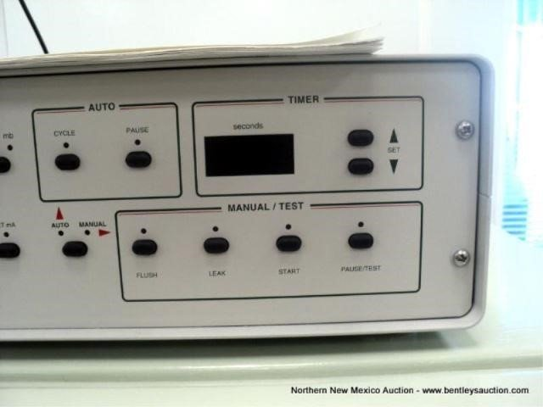

1. “Set” buttons
2. Auto / Manual switch
3. Pause / Test
4. Cycle

Figure 3,9 Cressington 108-Auto Gold Sputter-Coater controls

*Sputter Coater Operation: (Figure 3.8 and 3.9)*

* 1. Ensure that gas supply valve is open
  2. Open lid and remove glass cylinder
  3. Place prepared slide on “platform” (inside the glass which was just removed)
  4. Replace glass cylinder
  5. Turn on sputter-coater with switch on carbon coater unit (right)
  6. Press lightly on lid to ensure good vacuum seal (vacuum indicated by gage)
  7. Select “Manual” mode
  8. Hold “Pause/Test” button and use ”Set” buttons to select desired operation time
  9. Select “Auto” mode
  10. Press “Cycle” to initiate the automatic coating cycle
  11. When timer has expired, shut off sputter-coater with switch on carbon coater unit
  12. Once chamber vacuum has been vented, sample may be carefully removed
  13. Close the gas supply valve when finished using the equipment

1. After the specimen has been coated, the masking is removed, and a simple plastic cutlery knife is then employed to remove a small portion of the Au film in a direction perpendicular to the step created by the masking.
2. Using carbon tape, the 90-degree “step” geometry which was produced is centered on and adhered to a magnetic disc for use inBruker Atomic Force Microscope (AFM). A prepared magnetic disc with two pieces of carbon tape (paper backing still present) is shown in *Figure 3.10* below. It is *highly* recommended that the area to be scanned be located directly above the carbon tape as the black tape facilitates easier visual location of probe with region to be scanned.

Figure 3.10 Magnetic disc with carbon tape prepared for sample scanning with AFM

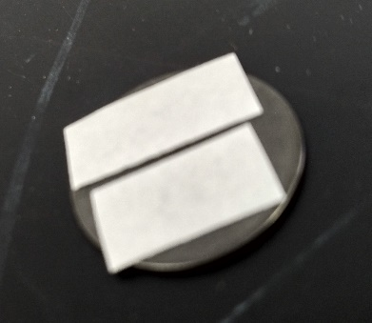

1. In contact mode configuration, each “step” is scanned over a range of 50μm X 50μm. Topological data of the “step” region is then recorded (shown as viewed through optical microscope display from AFM in *Figures 3.11 and 3.12* below). AFM operation requires proper training which can be acquired through appropriate personnel (For our case, instrument innovator Emily Kopp provided training upon receipt of email inquiry).

Figure 3.11 Contact probe scanning using AFM

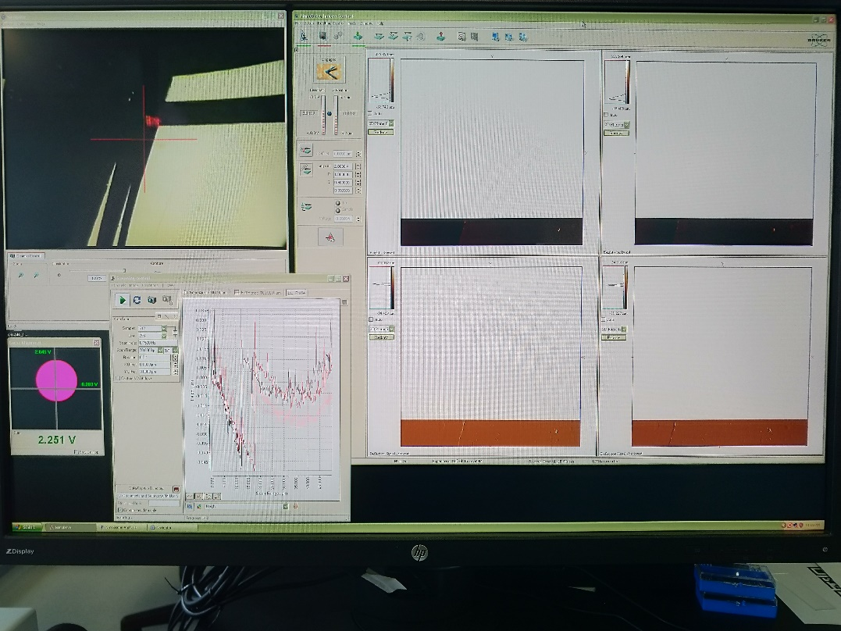

Figure 3.12 Optical microscope view of “90-degree step geometry” produced using combination masking technique and plastic knife

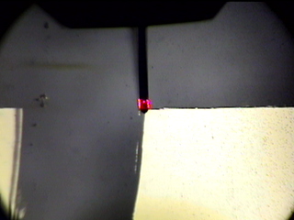

1. Contact probe (AFM)
2. “Step” created by plastic knife method
3. “Step” created by clear tape masking
4. Secondary analysis of topological data is performed using image post-processing software on AFM computer as well as Gwyddion, a 64bit free-source software commonly used in AFM scan post-processing.
   1. Open the saved scan in Gwyddion (*Figure 3.13*)

Figure 3.13 Selecting saved scan for analysis in Gwyddion software

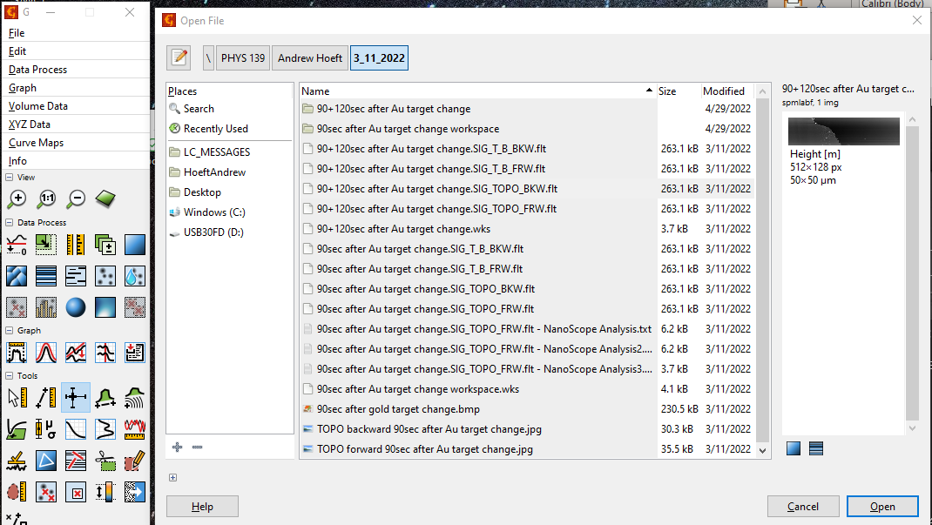

* 1. Use “level data to make facets point upwards” function (*Figure 3.14*).

Figure 3.14 Gwyddion functions menu

“Level data to make facets point upwards” function

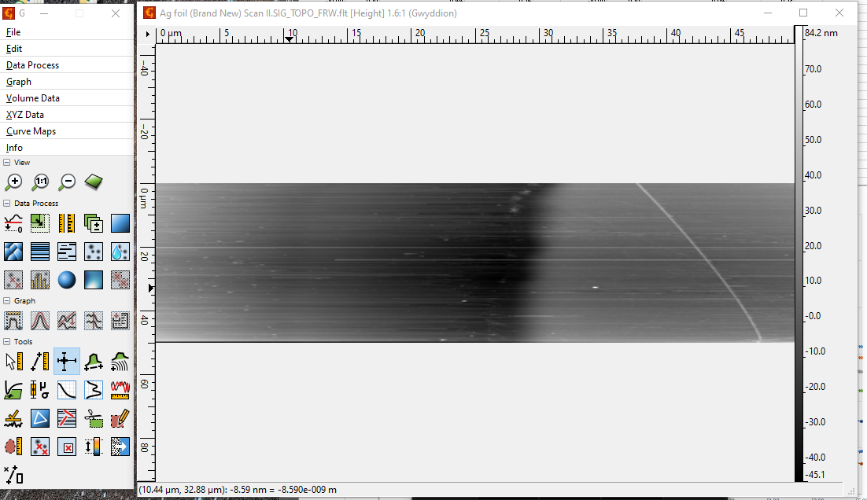

“Read horizontal and/or vertical profiles” function

* 1. Select “read horizontal and/or vertical profiles function from menu (*Figure 3.14*). Gwyddion will then generate a cross-sectional profile for each line drawn (by the user) on the topological scan (*Figure 3.15*). Drop-down menu(s) on the lower right allow for refinement of data analysis.

Figure 3.15 Cross-sectional analysis of topological scan data

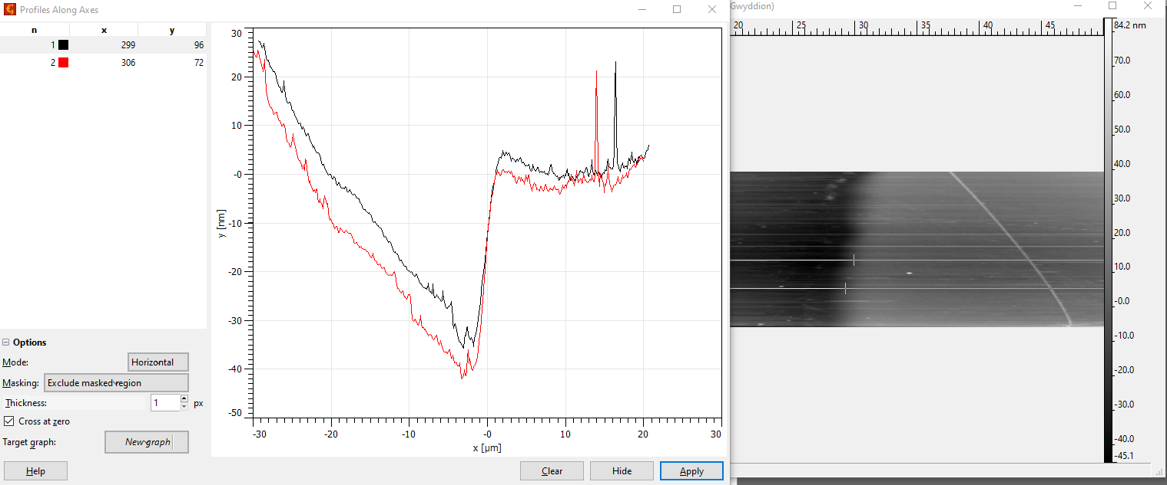

“Horizontal” or “Vertical” slicing selection

User defined “slices” through topological scan

* 1. When scanning large regions (50μm X 50μm and larger) it is typical to see “cupping” of the topological scan data, which often requires mathematical flattening techniques. It is important to note that even without flattening, the local cross-sectional data is sufficiently accurate (for x-value ranges of less than 5μm) to estimate the “step” height in a scan (*Figure(s) 3.15 and 3.16*).

Figure 3.16 Estimating “step” height using a cross-section

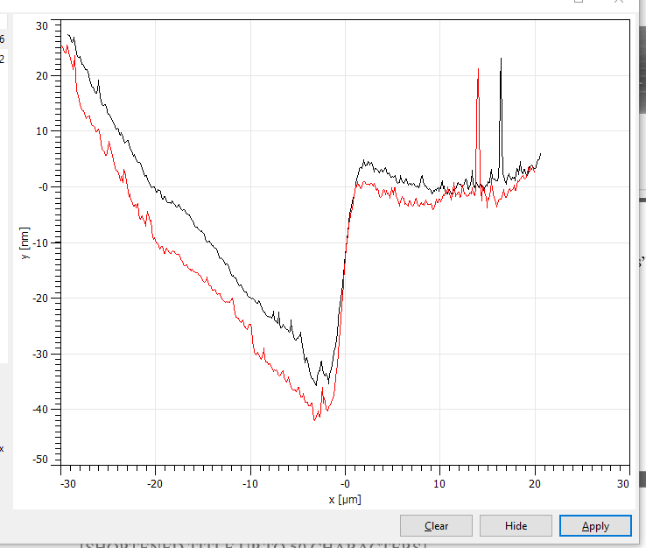

Approximate “step” height of 40-45nm

* 1. Further refinement may be achieved by using “Apply” and then “Zoom in by mouse selection” (*Figure 3.17*). Simply “zooming in” is enough to visibly “flatten” the data significantly.

Figure 3.17

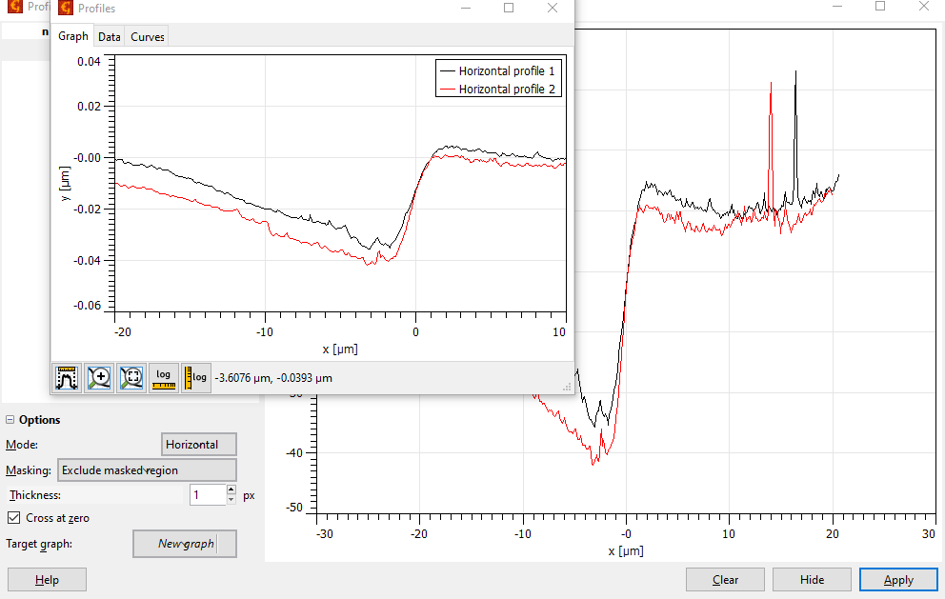

“Apply” button

“Zoom in by mouse selection” button

### Data collection.

1. The “zero” position of stage turntable (where the slide is oriented perpendicular to the incident light from the LED source) is noted, for our configuration this was the 250-degree mark on the turntable as described under configuration.
2. **(Projection onto screen)** With the slide positioned in the stage as per experimental configuration A, the LED power is set to full using the controller and the iris aperture is set to desired diameter. The stage is then rotated through a range of theta values, ensuring that the polarimeter is alternated between surface and plane polarization, and the reflected light is observed and analyzed. In the even that SPR is achieved, and no intermediary conditions exist, a vertical band of noticeably lower intensity is expected to present in the reflected band of light when the light is plane-polarized and will “vanish” when the polarimeter is adjusted to allow surface-polarized light to pass (*Figure 3.1* demonstrates visual projection of SPR).

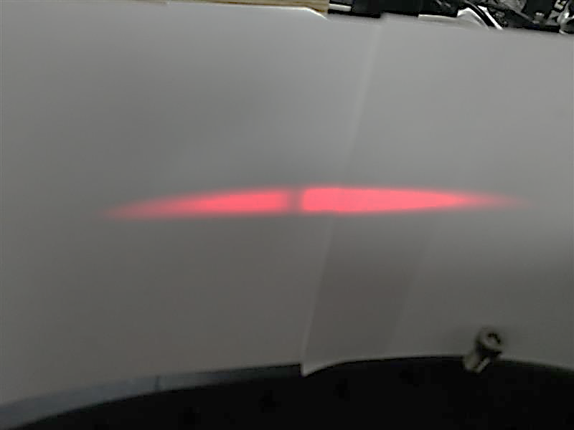

Figure 3.1 Visual projection of SPR phenomenon

1. **(Measurement using photodetector)** If using experimental configuration B, photodetector is powered on, the sensor is covered so that it observes zero light exposure, and the instrument is zeroed to ensure calibration (this is a manual function performed by the user with the console). Upon successful sensor calibration, the lens cap is removed, and the sensor is positioned to be centered in the plane of reflected light and measured value of ambient light intensity is noted (see *Figures 3.4 and 3.5* under **procedure***)*.
2. With the slide positioned in the stage as per experimental configuration B, the LED power is set to full using the controller and the iris aperture is set to desired diameter (there is a setting on the PM100D console which should be adjusted for the anticipated diameter of the reflected light at the point where it interfaces the sensor).
3. For each theta, the arm which positions the photodetector should be rotated so that the reflected light is positioned as centrally as possible on the sensor. The polarimeter should then be set to the desired orientation for polarization of incident light (for our experiment, a reference value of 45 or 225 degrees corresponded to surface-polarization, implicitly defining a reference value of 135 or 315 degrees to correspond to plane-polarization). A value for the intensity of reflected light is then acquired from the sensor and logged.
4. Incident light intensity is then quantified through use of the same photodetector which was leveraged in quantifying reflected light (to ensure that all measurements were obtained using the same sensor for the purpose of eliminating possible variance). Each value of reflected light intensity is then converted to a unitless reflectance using the ratio:

**Equation 3.1**

$$ρ=\frac{ϕ_{r}}{ϕ_{i}}$$

Where $ρ$ is reflectance, $ϕ_{r}$ is the radiant flux reflected from surface, and $ϕ_{i}$ is the incident radiant flux

# 4) Results

## Topological scanning using AFM

Figure 4.1 Topological scan of “step” created by 150 second Au deposition



1. “Horizontal profile 1 (referenced in Figure 4.2)
2. “Horizontal profile 2 (referenced in Figure 4.2)
3. Step created by clear tape masking technique

Figure 4.1 (above) displays scan data acquired through use of AFM of a “step” created by clear tape masking technique (outlined in procedure section) The scan is then loaded into Gwyddion software for “slicing” and cross-sectional profile analysis (Figure 4.2).

Figure 4.2 Cross sectional analysis using Gwyddion of scan shown in Figure 4.1 (150 seconds of Au sputter-coating)

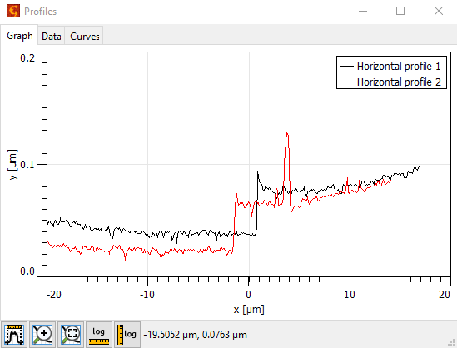

Figure 4.3 Topological scan of Ag (standard) at corner location

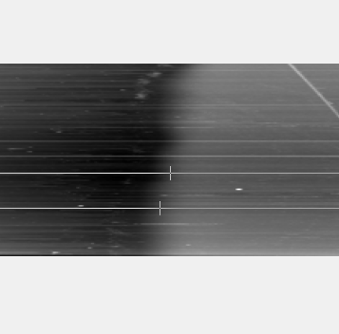

Figure 4.4 Cross-sectional analysis using Gwyddion software of scan shown in Figure 4.3 (Ag experimental standard)

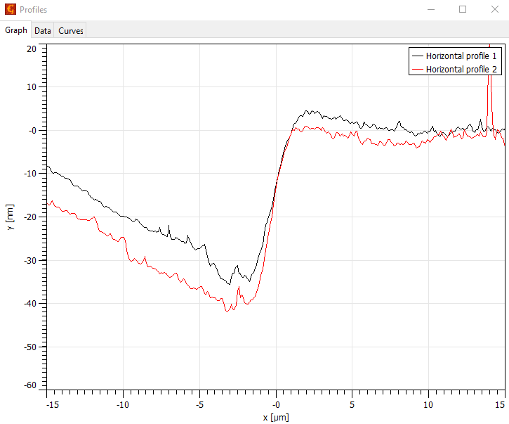

Figure 4.5 3-Dimensional representation of scan from Figure 4.3

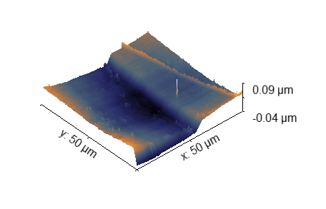

Figure 4.6 Topological scan of “step” created by 180 second Au deposition

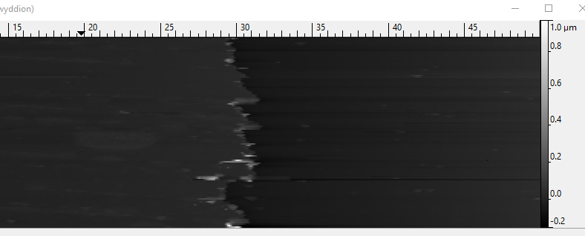

Figure 4.6 3-Dimensional view of cropped region from scan shown in Figure 4.5

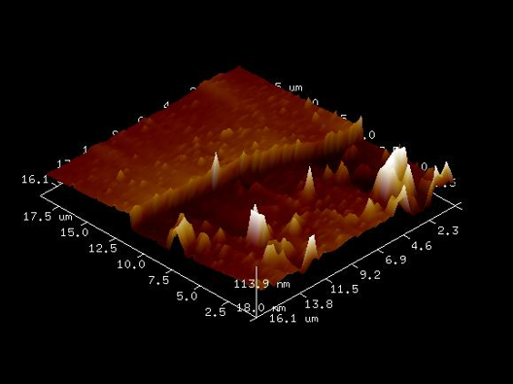

Figure 4.7 Cross sectional analysis of topological scan shown in Figure 4.5

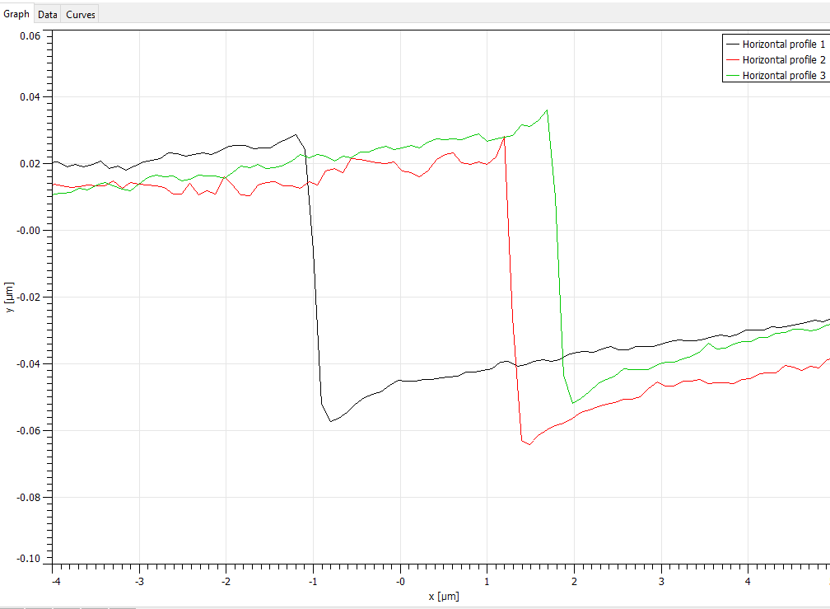

## Experimental data

Table 4.1 Specimen Identification Information for Charts 4.1 through 4.4

|  |  |  |
| --- | --- | --- |
| **Specimen ID** | **Sputter-Coating Time / Film Thickness** | **Side Coated** |
| A3 | 180 seconds | Un-etched side |
| A4 | 180 seconds | Etched side |
| A5 | 180 seconds | Un-etched side |
| A6 | 180 seconds | Etched side |
| (Standard) | 50 nm | n/a |

Table 4.1 denotes side coated with film during production of specimen (see Methodology: Preparation of specimen and analysis of film thickness) as well as coating time (thickness analysis in greater detail in previous section).

*Chart 4.1* (below) represents measured reflectance for two iris diameters and a single specimen (Ag film experimental standard), where the iris diameter for the data series “Trial 1” was approximately twice that of the diameter for data series “Trial 2.”

Chart 4.1

*Chart 4.2* (below) represents measured reflectance for two iris diameters and two Au film specimens, where the iris diameter for the data series “Trial 1” was approximately twice that of the diameter for data series “Trial 2” and “Slide A3” was produced with the Au film opposite the etched side while “Slide A4” was produced with Au film on the same side as the etched surface (see Methodology: Preparation of specimen and analysis of film thickness.)

Chart 4.2

*Chart 4.3* (below) represents measured reflectance for one iris diameter and two Au foil specimens plotted against data from two iris diameters and a single Ag foil (control) specimen, where the iris diameter for the Ag film data series “Trial 1” was approximately twice that of the diameter for data series “Trial 2” and “Slide A5” was produced with the Au film opposite the etched side while “Slide A6” was produced with Au film on the same side as the etched surface (see Methodology: Preparation of specimen and analysis of film thickness.)

Chart 4.3

*Chart 4.4* (below) represents all datasets for trials E and F, where two iris diameters were used, where “Trial 1” iris diameter was approximately twice that of the diameter used for “Trial 2” and “Trial 3” which maintained approximately identical iris diameter. Au film specimens (slides) A3-A6 and Ag experimental standard are the same slides represented in the previous charts.

Chart 4.4

# 5) Discussion

## SPR Determinations

When observing the results gained from the research completed there is insight to glean. Starting with the critical angle and indices of refraction. Using equation 2.1 and knowing that the index of refraction for the crown glass semi-cylindrical prism is roughly 1.5 and from chart 4.3 the average incident angle where minimum reflectivity is observed at an average 42.8°. From this the calculated index of refraction of the gold film cannot be calculated. This is most likely due to an inaccurate angle of SPR. The inaccuracies developed from the factors that are influencing SPR such as the film material, film thickness, incident angle, iris diameter, interface roughness, and material contaminations.

The angle of SPR was anticipated to be consistent throughout the same sided trials, but due to the large step size of 1° intervals and human approximations the angle measurements produce large error.

Measuring the thickness of the deposited gold film with the AFM gave an approximate 8.3 nm of gold every 30 seconds in the sputter coater. Therefore, a time of 180 seconds would produce a gold film of approximately 50 nm which matched the silver film thickness.

Analyzing the data from chart 4.4 the 50 nm silver film produced SPR at 46°. It was anticipated to see the gold film to have SPR around a similar angle. The silver produced an average drop in reflectivity around 7% which was visible. The gold produced an average drop in reflectivity around 2% for trial 1 but produced an increase in reflectivity for all subsequent trials. This data was completely unexpected and remains an anomaly.

The material of the dielectric film from chart 4.4 seemed to shift the angle of SPR but reflectance stayed consistent. The thickness of the film changed the reflectance, but the shape of the curve did not. Iris diameter led to the anomalies of reflectivity increase. The interface itself seemed to cause damping of the evanescent wave which caused the drop in reflectivity to greatly diminish. The angle of incidence does affect if SPR occurs since SPR happens at certain angles for certain materials.

### Future Research

Early in the research it was planned to achieve SPR consistently and apparent with the gold film. If it were achieved there would be potential exploration of utilizing different mediums beyond the film. Potential use of a laser instead of a LED light source may prove an interesting pursuit. Piranha cleaning of a float glass slide was another option to quantify the effect of residual zinc and roughness of the float glass. The cleaning technique is available in the UW Stout labs, but due to time constraints was unachievable. Possible explanation for the increase in reflectivity and attempted recreation of the phenomena.

References

Cavalcanti, G. O., & Fontana, E. (2009). Hydrogen Detection Using Surface Plasmon Resonance in Palladium Films. *International Microwave & Optoelectronics Conference .* doi:DOI: 10.1109/IMOC.2009.5427576

Pattnaik, P. (2005). Surface plasmon Resonance Applications In Understanding Receptor-Ligand Interaction. *Applied Biochemistry and Biotechnology*, 79-92.

Pedrotti, F. L., Pedrotti, L. M., & Pedrotti, L. S. (2017). *Introduction To Optics Third Edition.* Cambridge: Cambridge University Press.

1. With regard to the standardization of microscope slides: There is in fact quite a large degree of difference between different grades. The authors of this work had initially intended to utilize an array of slides of differing grades and degrees of prior use without awareness/knowledge of this difference. All slides utilized in this experiment were speculated (determined?) to have been manufactured using the float glass method. Therefore, each slide would possess an “air” side and a “zinc” side, where the “air” side was open to air during the manufacturing process and the “zinc” side was exposed to molten zinc. The “zinc” side is left with a not insignificant quantity of Zn residue, which may result in an impact on conductivity and optical properties.
2. It should be noted that the Au “target” in the sputter coater was adjusted / realigned (not by the authors of this paper) between the production of the first and second half of test specimens (collectively) in the event that this is determined to have had any effect on the Au film coatings